**UNIT-IV: Lasers and Fibre Optics**

Lasers: Introduction to interaction of radiation with matter, Coherence, Principle and working of Laser, Population inversion, Pumping, Types of Lasers: Ruby laser, Carbon dioxide (CO2) laser, He-Ne laser, Applications of laser. Fibre Optics: Introduction, Optical fibre as a dielectric wave guide, Total internal reflection, Acceptance angle, Acceptance cone and Numerical aperture, Step and Graded index fibres, Losses associated with optical fibres, Applications of optical fibres

**UNIT-4**

**Chapter-1: LASERS**

**LASER:-**

**Definition:-**

“Laser is a device to produce a powerful monochromatic beam of light in which the waves are coherent”.

The word ‘LASER’ is an acronym for ‘Light Amplification by Stimulated Emission of Radiation.

i.e, Laser radiation is due to stimulated emission process which amplifies (improves) the intensity of radiation.

In 1954, Charles H.Townes invented a microwave device ‘MASER’, which is an acronym for ‘Microwave Amplification by Stimulated Emission of Radiation. Maser has frequency up to 1010Hz.

In 1960, T.H. Maiman invented the Ruby laser. It is the first laser. LASER has frequency 1014 to 1016Hz.

**CHARACTERISTICS OF LASER:- [5M]**

Lasers differ from conventional light sources in a number of ways. The most important characteristics of a laser beam are

1. High Monochromaticity.
2. High Coherence
3. High Directionality
4. High Intensity

**1. Monochromaticity:-** Laser has only single wave length, where as the ordinary light sources like, tube light, mercury vapour lamp… etc, have many wave lengths.

In laser radiation, all the photons emitted between discrete energy levels will have same wavelength. As a result the radiation is monochromatic in nature.

Let ∆ν, ∆λ are the spread in frequency and wavelength having ranges ν+∆ν and λ+∆λ respectively.

Then,

∆λ= -[c/ν2] ∆ν

For laser, ∆λ= 0.001nm. It is clear that laser radiation is highly monochromatic.

**2. Coherence:-**

When two waves (photons) having same amplitude, same frequency and phase difference between them is constant (or) zero, moving along the same direction, they are called coherent waves.

Coherence is a property of a wave being in phase with itself and also with another wave over a period of time, distance and space. Coherence is of two types:

i. Temporal coherence ii. Spatial coherence.

**i).Temporal Coherence:-**

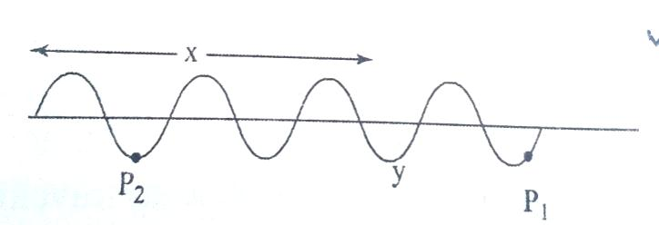If a wave has same amplitude and frequency at all points on the wave over a period of time, throughout its motion, is called as temporal (or) longitudinal coherence.

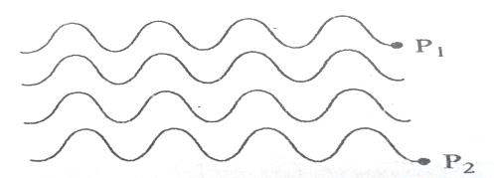**ii). Spatial Coherence:-**

If two waves are having same amplitude, same frequency and the phase difference between them is zero (or) constant over a space, throughout its motion, is called as spatial (or) transverse coherence.

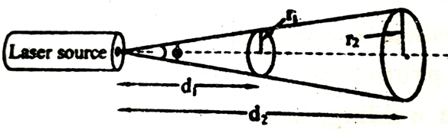**3.Directionality:-**

Ordinary light spreads in all directions and its angular spread is 1m/meter. But laser is highly directional and its angular spread is 1mm/meter.

The laser light of wave length ‘λ’ emerges through a laser source aperture diameter‘d’, then it propagates as a parallel beam and gets diverged as shown in fig.

The angle of divergence of a laser beam is, φ = =

Where r1, r2 are radii of the laser spots measured at distance d1& d2 from the laser aperture (or) source.

For laser light, φ = 10-3 radians.

**4. Intensity or Brightness:-**

Due to high coherence and high directionality of laser, gives the high intensity (or) brightness laser beam.

Let there be ‘n’ no of coherent photons of amplitude ‘a’ in the emitted laser radiation.

Resultant amplitude of wave is ‘na’. Therefore, the intensity of laser beam is, I α n2 a2

**BASIC DEFINITIONS:-**

**Induced (or) Stimulated Absorption:-**

An atom in the lower energy level (or) ground state energy level E1 absorbs the incident photon and goes to excited state (E2) as shown in fig. this process is called an induced or stimulated absorption.

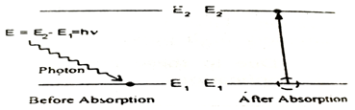

Here the energy of absorbed photon is equal to the difference between two energy levels.

i.e, E= hν (or) E2-E1=hν

The probability of induced absorption transition from state 1 to state 2 (P12 ) depends on the properties of states 1&2 and is proportional to energy density u(v) of radiation of frequency ‘ν’ incident on the atom.

Thus, P12 α u(ν) (or) P12= B12 u(ν) ……………..(1)

Where B12= Einstein's co- efficient of induced absorption of radiation.

**EMISSION:-**

Normally the atoms excited to higher (excited) state, will not stay for a long time, after a short period of time (10-8sec) come to ground state by emitting a photon of energy E= hν.

This emission will takes place in two ways. They are,

1. Spontaneous emission

2. Stimulated emission

**1. SPONTANEOUS EMISSION:-**

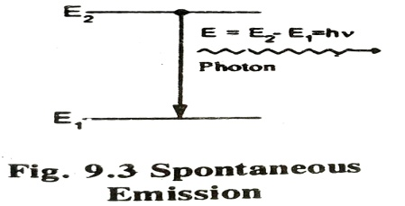The atom in the excited state returns to ground state by emitting a photon of energy E= (E2-E1) = hν, without applying an external energy (spontaneously).

This process is called as spontaneous emission.

The probability of spontaneous emission transition from state 2 to 1 (P21) depends only on the properties of states 1 &2. It is independent of u (ν) .

, ………….(2)

(P21) spontaneous= A21

A21

Where, A21 = Einstein’s co-efficient of stimulated emission.

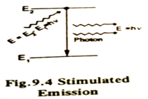**2. Stimulated Emission:-**

The atom in the excited state can also return to the ground state by applying external energy or inducement of photon there by emitting two photons which are having same energy as that of incident photon. This process is called as stimulated emission.

The probability of stimulated emission transition from state 2 to state 1 (P21) is proportional to the energy density u(ν) of stimulating radiation.

i.e., P21 α u (ν) (or) P21= B21 u(ν) …….(3)

Where B21 = Einstein’s co-efficient of stimulated emission of radiation.

**\*\*\* Relation Between Einstein’s Co-efficients (A&B):-**

Consider two energy levels of energies E1 & E2 such thatE2> E1. LetN1 , N2 are the no. of atoms per unit volume of E1 & E2 respectively. The no. of atoms in state 1, absorb a photon and rise to state 2. i.e., the no. of induced absorption of radiation, N1 P12 = N1 B 12 u(υ) ----------------------(4)

The no of atoms in excited state2, come to ground state1, causes spontaneous emission & stimulated emission.

i.e., N2 P21 = N2 [A21 + B21 u(υ) ] ----------------------(5)

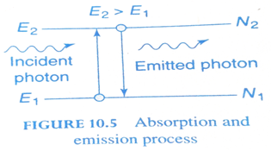

For equilibrium, the absorption & emission must occur equally, hence

N1 P12 = N2 P21

N1 B 12 u(υ) = N2 [A21 + B21 u(υ) ]

N1 B12u(υ ) = N2 A21+ N2 B21u(υ )

N2 A21 = N1 B12 u(υ )- N2 B21u(υ )

N2 A21  = u(υ ) [N1B12  - N2B21]

u (υ) =

=

u (υ)  **= -----------(6)**

According to Boltzmann’s distribution law,the no of atoms of any energy level E, at temperature ‘T’ is given by

N = N0

Then, N1 =N0 and N2 =N0

N1 / N2 = e(E2- E1) / kBT

N1 / N2= ehυ / kBT [ since E2 – E1 =hν ]

Substituting the value of N1 / N2 in eqn (6), we get

u(υ) = ** -----------------(7)**

According to Planck’s radiation law,

Eν = ------------(8)

Comparing equations(7) and (8) ,we get

i) B12 = B21 ; and ii) = ; i.e. α ν3

i.e, First relation shows the rate of probability of induced absorption and emissions are equal.

Second relation shows that the ratio of A21 and B21 is proportional to cube of the frequency of incident photon.

**\*Distinguish between Spontaneous Emission&Stimulated Emission:-**

|  |  |
| --- | --- |
| **Spontaneous Emission** | **Stimulated Emission** |
| 1.It takes place without anyexternal energy | 1. It takes place with the help of anyexternal energy |
| 2.It is incoherent radiation | 2. It is Coherent radiation |
| 3. It is Low intense and less directional | 3. It is High intense and more directional |
| 4. It is Poly chromatic radiation | 4. It is Monochromatic radiation |
| 5.It is postulated by Bohr | 5. It is postulated by Einstein |
| 6.Ex:- Light from Na, Hg lamp | 6.Ex:- Light from Ruby,He-Ne laser |

**Population:-**

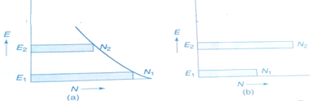

It is the number of atoms present in various energy levels. Normally,N1> N2 and E2>E1.

Ex:- Two energy level system as shown in fig.a.

**Population Inversion:-**

The state of achieving more number of atoms in the excited state compared to the ground state atoms is called as population inversion i.e, N2> N1.

Consider a two level energy system as shown in fig.b. E2 & E1 are the energies of ground &excited states respectively.N1, N2 be the no. of atoms in energy states E1, E2 respectively.

From Boltzmann distribution law, the no of atoms of any energy level E, at temperature ‘T’ is given by, N= N0 e-

==» N1/N2 = e ==» N2 > N1

i.e. In normal conditions, N1> N2 and E2 >E1

1.If N1> N2----Absorption takes place

2. If N2 > N1…..Stimulated Emission takes place

It is called as population inversion.Population inversion is achieved by Pumping process.

**LIFE TIME:-**

The time spent by the atom in excited is called the life time of that excited state. The life time of hydrogen atom is 10-8 sec.

**METASTABLE STATE:-**

The excited state which has long life time is known as Meta stable state. According to Heisenberg’s uncertainty principle,

Δ E . Δt ≥ , i.e., Δt α 1/ Δ E

Thus the life time of electron in the meta stable is increases as the width of the energy level decreases.

It is the intermediate energy level between excited state (E3) and ground state (E1). In Meta stable state the life time is 10-3 to 10-4s. So that the no. of atoms in the Meta stable state is more than in ground state.Hence population inversion is achieved.

**LASING ACTION (OR) PRINCIPLE OF LASERS ACTION:-**

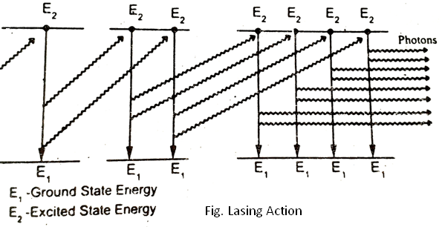

Let us consider many no. of atoms in the excited state.Now if one stimulating photon interacts with any one of the atoms in

the excited state, the stimulated emission will occur. It emits two photons, having same energy, same frequency and move in

same direction.

These two photons will interact with another two atoms in excited state and emit 4-photons of similar properties.Again these 4- photons will interact with more 4-photons in excited state and emit 8-photons.

In a similar way a chain reaction is produced. This phenomenon is called as lasing action.

So a monochromatic, coherent, directional and high intense term is obtained. This is called laser beam. This is the principle of working of a laser.

**\*\*\* Pumping Methods:-**

The process of raising more number of atoms from ground to the excited state by artificial means is called as pumping.

There are several methods to achieve population inversion. Some of the most commonly used methods are,

1. Optical pumping.
2. Direct electron excitation (or) electric discharge (or) Electricalpumping.
3. Inelastic atom- atom collision.
4. Direct conversion.
5. Chemical pumping.

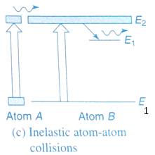**1.Optical Pumping:-**

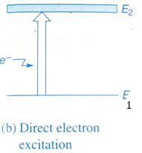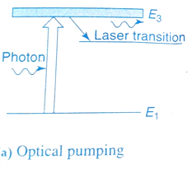

Here the atoms are excited by an external optical source like- Xenon flash lamp. The atoms absorb energy from photons of optical source & raises to excited state.

Ex:- Ruby laser, Nd-YAG laser.

**2. Electrical pumping(or) Electric discharge:--**

The electrons are accelerated to very high velocities by strong electric field and they collide with gas atoms & these atoms are raised to excited state.

Ex:- He -Ne laser, CO2 laser, Ar-ion laser.

**3.Inelastic atom- atom collision:-**

Here, the electric discharge is used to cause collision & excitation of the atom. In this method a combination of two types of gases is used, say A&B, both having the same excited states A* & B*.

In first step during electric discharge A gets excited to A*. i.e., A + e …….> A* + e1.

Now the excited A* atoms collide with B atoms. So that B gets excited to B*. i.e., A* + B……> A + B*

Ex:- He -Ne laser, CO2 laser

**4. Direct conversion:-**  Due to electrical energy applied in direct band gap semiconductor like GaAs etc., the combination of electrons & holes takes place & electrical energy is converted in to light energy directly.

Ex:- Semiconductor Laser

**5. Chemical pumping:-**

Due to some chemical reactions the atoms may be raised to excited state.

Ex:- HF-Laser, Dye Laser

**\*\* Construction & Components of a LASER:-**

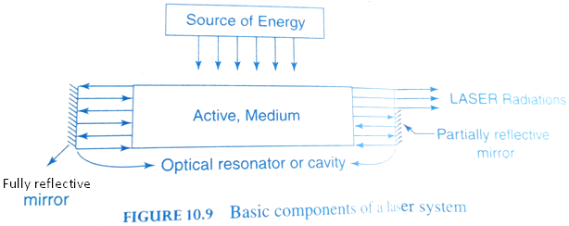

Any laser system consists of three important components.

They are, 1. Source of energy (or) pumping source

2. Active medium.

3. Optical cavity (or) resonator.

**1. Energy Source:-**

It supply energies and pumps the atoms or molecules in the active medium to excited states.As a result we get population inversion in the active medium which emits laser.

Eg: Xenon flash lamp, Electrical field.

**2.Active medium:-**

The medium in which the population inversion takes place is called as active medium.

**Active center:-** The material in which the atoms are raised to excited state to achieve population inversion is called as active center.

**3. Optical cavity (or) Resonator:-** The active medium is enclosed between a fully reflective mirror and a partially reflective mirror. This arrangement is called as optical cavity or resonator.

The reflecting portions of the mirrors reflect the incident radiation back into the active medium.These reflected radiations enhance the stimulated emission process within the active medium.As a result, we get high intensity, monochromatic, coherence laser light through the non-reflecting portion of the mirror.

**\* Types of LASERS:-**

Based on the type of active medium, lasers are mainly classified into five types.

They are,

1. Solid State Lasers:- Ex:-a). Ruby laser (3level laser), Nd-YAG Laser (4-level laser).

2). Liquid lasers:- Ex:- Organic dye laser

3. Gas lasers:- Ex: He-Ne laser,CO2 laser,Ar - ion laser.

4). Semi conductor lasers. Ex: GaAs, GaAlAs

5). Chemical lasers:- Ex:- HF, ArF

1. **\*\*\* RUBY LASER:-**

It is a three level solid state laser,discovered by T.H.Maiman in 1960.Ruby is a crystal made up of aluminium oxide (Al2 O3) in which Al+3ions are replaced by Cr+3ions doping 0.05% of Cr 2O3.

**Characteristics of Ruby laser:-**

1) Type: solid state laser; 2) active medium: ruby rod.3) active center:cr+3 ions.

4) Pumping method: optical pumping.5) pumping source: xenon flash lamp.

6) Optical resonator: two ends of the rod.7) power output: 104 to 105 watts.

8) Nature of output: pulsed. 9) Wavelength (λ): 6943 A0

**Principle:-**Due to the optical pumping chromium atoms are raised to excited states,then the atoms come to meta stable state by non-radiative transition.Due to stimulated emission the transition of atoms takes place from meta stable state to ground state and gives a laser beam.

**Construction:-**

The ruby rod is kept inside the glass tube.Xenon flash lamp is spirally wound over the surface of the ruby rod and is connected to a power supply.

Cooling arrangement is made to avoid heating in which liquid nitrogen or water may be circulated.The two ends of the rod, one is fully silvered and the other end is partially silvered as shown in the figure.

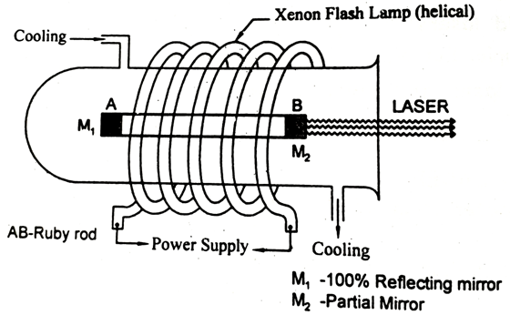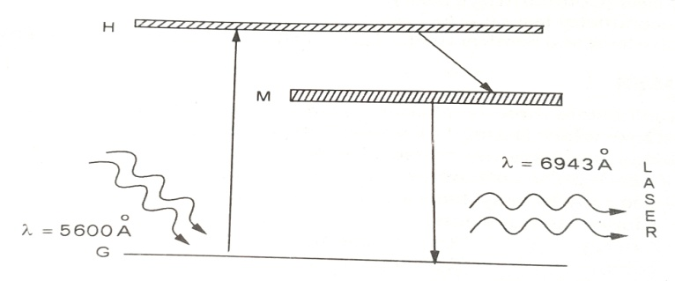

Fig.1 Ruby laser Fig.2 Energy Level Diagram

**Energy Level Diagram (ELD):-**  It is shown in fig.2

**Working:-**

1) The xenon flash lamp is switched ON and the light is allowed to fall on the ruby rod.

2) Optical energy excites the Cr- ions from ground state to excited state and the rest heats up the apparatus can be cooled by the cooling arrangement.

3) The Cr atoms absorb the photons of the wavelength 5600A0from flash tube and go to the E3 excited state.

4) These Cr atoms come to the meta stable state after staying for up to 10-8 seconds.

A non- radiative transition takes between E3 & E2.

5) In meta stable state (E2), number of Cr atoms are more and life time is 10-3s and hence population inversion is achieved.

6) the Cr atoms in meta stable state E2 come to ground state E1 by emitting a photon of wavelength λ= 6943 A0

7) This chain reaction is repeated by the optical resonator and produces high intensity, monochromatic, coherent and directional beam of wavelength λ= 6943 A0.

**Applications of RUBY LASER:-**

1) it is used in pulsed holography.2) it is used in LIDAR [Light Detection And Ranging]

3) it is used in Remote Sensing.4) it is used in Opthalmology.5) It is used in drilling small areas.

**Disadvantages:-**

1. it requires a high pumping power.2) the efficiency is very low.3) output is pulsed.
2. **\*\*\* Helium-Neon (He-Ne) LASER:-**

It is discovered by Ali Javan and his co-workers in 1960.It is a continuous wave gas laser.

**Characteristics of He-Ne Laser:-**

1) Type: gas laser 2) active medium: He-Ne in 10:1 3) active center: Ne

4) Pumping method: electrical pumping.5). Optical resonator= Silver coated mirrors.

d) Nature of output:- Continuous e) wavelength (λ )= 6328A0

**Principle:-** This laser is based on the principle of stimulated emission produced in the He- Ne.The population inversion is achieved due to the interaction between Heliumand Neon gases.

**Construction:-**

It consists of Quartz discharge tube and is filled with the mixture of He under the pressure of 1mm of Hg and Ne at 0.1mm of Hg in the ratio of 10:1. The electrodes at the ends of discharge tube are connected to the radio frequency oscillator to produce electrical discharge in He- Ne mixture.One end of glass tube is fully reflective to emit laser beam.

**Energy Level Diagram(ELD):-**

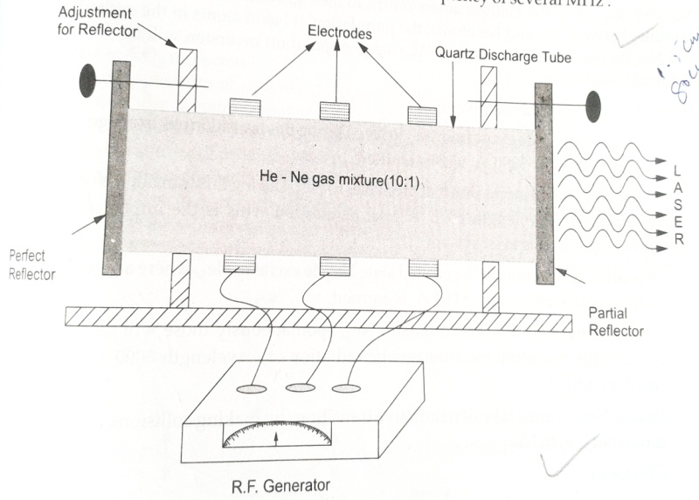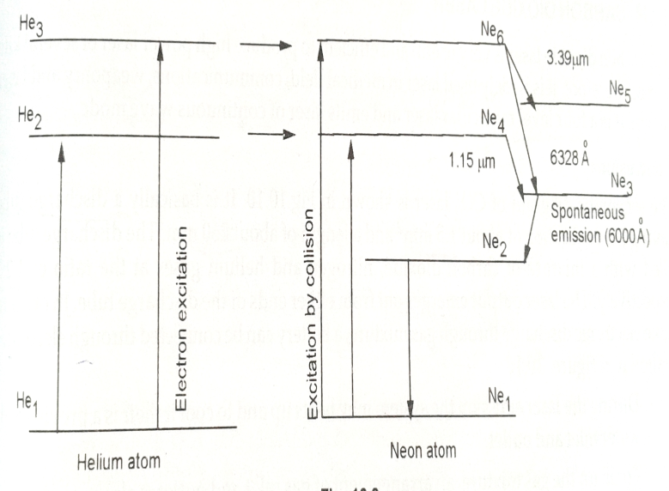

Fig.1 He-Ne laser Fig.2 Energy Level Diagram

**Energy Level Diagram(ELD):-**It is shown in fig.2

**Working:-**

1. Radio frequency oscillator is switched on and it produces the electrical discharge in He-Ne mixture.

2. By absorbing electrical energy,Helium atoms in the ground state are raised to excited states.

3. These excited He–atoms collide inelastically with the Ne-atoms. Then Ne-atoms also reached to excited states.

4. Population inversion is achieved in E4 &E6.

5. Now Ne atoms again come to ground state through different transitions in various states.

6. Stimulated emission takes place between E6 &E5 and emits the radiation of (λ )= 3.39μm

7. Stimulated emission takes place between E6 &E3 and emits the radiation of (λ )=6328 A0

8. Stimulated emission takes place between E4 &E3 and emits the radiation of (λ )= 1.15 μm

9. Spontaneous emission takes place between E3&E2 and emits the radiation of (λ )= 6000 A0.

10. The ne-atoms come to ground state by non-radiative transition.

11. The excitations and de-excitations of He & Ne atoms is a continuous process and produces an intensity,coherent, monochromatic and directional laser beam of wavelength (λ )= 6328A0.

**Applications:-**

1. it is used in open air communications. 2. it is used to produce holograms.

3. it is used to determine the size of tiny particles

**CO2 LASER**

**Construction and working:**

We know that a molecule is made up of two or more atoms bound together. In molecule in addition to electronic motion, the constituent atoms in a molecule can vibrate in relation to each other and the molecule as a whole can rotate. Thus the molecule is not only characterized by electronic levels but also by vibration and rotational levels. The fundamental modes of vibrations of CO2 molecule shown I fig.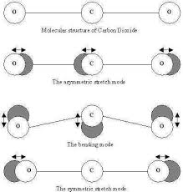

CO2 Laser is a gas discharge, which is air cooled. The filling gas within the discharge tube consists primarily of, CO2 gas with 10 – 20%, Nitrogen around 10 – 20 % H2 or Xenon ( Xe ) a few percent usually only in a sealed tube.

The specific proportions may vary according to the particular application. The population inversion in the laser is achieved by following sequence:

1. Electron impact excites vibration motion of the N2. Because N2 is a homo nuclear molecule, it cannot lose this energy by photon emission and it is excited vibration levels are therefore metestable and live for long time.

2. Collision energy transfer between the N2 and the CO2 molecule causes vibration excitation of the CO2, with sufficient efficiency to lead to the desired population inversion necessary for laser operation.

Because CO2 lasers operate in the infrared, special materials are necessary for their construction. Typically the mirrors are made of coated silicon, molybdenum or gold, while windows and lenses are made of either germanium or zinc sulenide. For high power application gold mirrors and zinc selenide windows and lenses are preferred. Usually lenses and windows are made out of salt NaCl or KCl ). While the material is inexpensive, the lenses windows degraded slowly with exposure to atmosphere moisture.

The most basic form of a CO2 laser consist of a gas discharge ( with a mix close to that specified above) with a total reflector at one end and an output coupler ( usually a semi reflective coated zinc selendine mirror ) at the output end. The reflectivity of the out put coupler is typically around 5 – 15 %. The laser output may be edge coupled in higher power systems to reduce optical heating problems.

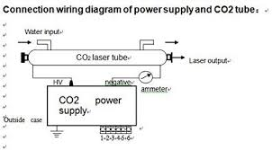 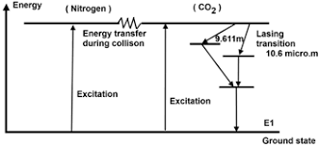

CO2 lasers output power is very high compared to Ruby laser or He – Ne lasers. All CO2 lasers are rated in Watts or kilowatts where the output power of Ruby laser or He – Ne laser is rated in mill watts. The CO2 laser can be constructed to have CW powers between mill watts and hundreds of kilowatts.

1. **\*\*\* Semiconductor Laser:-**

The first semiconductor lasers were made by Hall and Nathan in 1962 using Gallium Arsenide(GaAs). The semiconductor laser is also called as diode laser. It has same principle like light emitting diode (LED).

On the basis of recombination, semiconductor lasers classified into two types. They are

(i) Home junction semiconductor laser. (Ex:-GaAs)

(ii) Hetero junction semiconductor laser. (Ex:-GaAlAs)

**(i).*** Home junction semiconductor laser(or) GaAs laser:-**

If junction is formed between p-type and n-type semiconductors of same type material, it is called as home junction semiconductor laser.

**Characteristics**:-

(i) Type:-Semiconductor laser (ii)Active medium: P-N junction diode (iii) Active center:- Recombination of electrons& holes (iv)Pumping method: Direct pumping (v)Optical Resonator: junction of diodes polished (vi) Output power:1mw

(vii)Nature of output : continuous (or)pulsed (viii) Wavelength=8400 to 8800 A0.

**Principle:-** When the P-N junction is forward biased, the width of the depletion region decreases, allowing more no. of electrons from n-type to cross the junction and recombine with holes in P-type.

Thus recombination of electron hole pairs across the junction and emits the radiation (photons) as shown in fig.2&3.

**Construction:**-

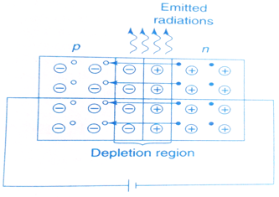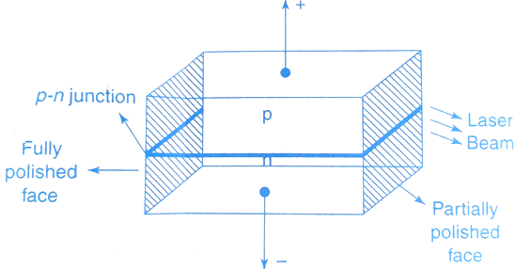

fig.1 GaAs laser fig.2 Forward biased P-N junction

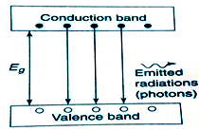

The GaAs laser was constructed by Hall. It is shown in fig.1. A rectangular block of GaAs semiconductor is converted into P and N- type by proper doping of impurities into the block.

The upper region acts as p-type and lower region acts as n-type. Between these two regions, a p-n junction is formed. To achieve population inversion p and n regions are heavily doped with the impurities. Two faces of the block, one is fully polished and the other partially polished, act as an optical resonator or cavity.

Fig.3 Energy Level Diagram

**Energy Level Diagram(ELD):-**It is shown in fig.3

**Working**:-

When the p-type is connected to the positive (+ve) terminal of a battery and n-types is connected to the negative ( –ve) terminal of a battery, and then the junction is in forward biased condition as shown in fig.2.

When the junction is forward biased, the width of the depletion region decreases, allowing more no. ofelectrons from n-type to cross and recombine with hole in P-type. Thus, the recombination of electron-hole pairs takes place across the junction and emits the laser radiation or photons.

The energy of emitted laser radiation is given by, E = hν(or)

Energy gap Eg = hν =

Wavelength of laser is, λ =

Where, h is Planck’s constant and c is Velocity of light.

* For GaAs semiconductor, **Eg**= 1.4ev, therefore the wavelength is, λ = 8874 A0

We get light in the infrared region.

**Advantages**:- (i) Its efficiency is high (ii) Output is tunable (iii) the laser output can be modulated within the semiconductor itself (iv) laser output is pulsed or continuous.

**ii. HETERO-JUNCTION SEMI CONDUCTOR LASER:-**

If junction is formed between p-type&n-type semiconductors of different materials, it is called as hetero junction semi conductor laser.

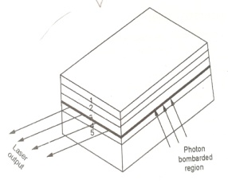 The working principle is same for the both homo&hetero junction semiconductor lasers.

Ex:-GaAlAs.

It is shown in fig. itconsists of various layers like1,2,3,4&5.The laser emission take place between 2&4 layers.

**\*\*\* APPLICATIONS OF LASERS:-**

It has many applications in various fields. They are

1.LASER IN COMMUNICATIONS:-

a) A laser beam has very large band width.A single laser beam can carry a single of band width

b)Fiber optics:-A laser beam in conjuction with optical fiber can be used to transmit audio,video signals over

long distance without much loss (or)attenuation.

c)laser is used in under water communication networks.

d )laser is used to send simultaneous telephone conversations(or)8000 TV programmes.

2.LASER IN MEDICINE:-

a) Opthalmology:-treatment of detached retina.

b)Neuro surgery:-treatment of lisure in skull &spine.

c)Gastro enterology:-treatment of coagulation of lower gastro interfinal tract.

d)Dermatology:-removal of skin imperfections’.

e)Gynecology:-fertility micro surgery

f)ENT:-ear,nose&throat surgery. g)Cancer diagnosis&therapy h)Destroying kidney stones.

3.LASER IN INDUSTRY-MATERIAL PROCESSING:-

a)material processing in values cutting,welding,hole drilling,evaporation&surface treatment.

b)laser are used to cut glass&quartz. c)laser are used to drill holes in ceramics.

d)laser are used for heat treatment in the fooling&automotive industry

4.LASER IN SCIENTIFIC FIELD:-

a)laser are use for isotope separation.

b)laser are use for to study the internal structure of micro organisms & cells.

c)laser are use to create plasma. d)laser are use to produce chemical reactions.

e)laser are use in metrology. f)laser are use in research lads

5.LASER IN COMPUTERS:-

a)To transmit memory banks from one computer another. b)Laser printers.

c)3D-profiling. d)To store data in CD-ROM,CD,DVD

e)Reading the data from CD,DVD,CD-ROM

6.LASER IN ELECTRONIC INDUSTRY:-

a)It is used to scribing in ceramic & semi conductor waters.

b)Laser are use to soldering for silver, platinum.c)Laser are use in super market scanners.

7.LASER IN MILITERY APPLICATIONS:-

a)DEATH RAY:-Laser beam is used to destroy very big objects like aircrafts,missiles.

b)LASERGUN:-laser is focused in every target at a short rang.this can evaporate the vital part of the enemy body. a)A huge amount of data can be stored.

c)LIDAR:-laser is used for light defection & ranging.

8.LASER IN HOLOGRAPHY:-

**\* * What are the different between a Laser diode and an LED?**

|  |  |
| --- | --- |
| **Laser Diode** | **LED** |
| 1Stimulated emission is possible in a laser diode. | 1.Spontaneous emission is possible In LED. |
| 2.Output beam is coherent. | 2.Output beam is non-coherent. |
| 3.Data rate is very high. | 3.Data rate is low. |
| 4.Sensitive to temperature. | 4.Not sensitive to temperature. |
| 5.Coupling efficiency is high. | 5.Coupling efficiency is low. |
| 6.Expensive. | 6.Cheap in cost |

**Formula:**

Energy gap of a semiconductor, Eg = hυ = joules

Eg= eV, since 1 eV = 1 Joules, Where, h = Planck’s constant = 6.63 x 10-34 j-s and

c = velocity of light = 3x108 m/s.

**Solved Problems:-**

**Example.1 ‑‑‑‑‑‑‑‑‑‑‑‑‑‑‑‑‑‑‑‑‑‑‑‑‑‑‑‑‑‑‑‑‑‑‑‑‑‑‑‑‑‑‑‑‑‑‑‑‑‑‑‑‑‑‑‑‑‑‑‑‑‑‑‑‑‑‑‑‑‑‑‑‑‑‑‑‑‑‑‑‑‑‑‑‑‑‑‑‑‑‑‑‑‑‑‑‑‑**

**A semiconductor diode laser has a peak emission wavelength of 1.55 μm. Find its band gap in eV**.

**Sol:** Energy gap of semiconductor, Eg = energy of emitted photon, hν

Wavelength, λ = 1.55 μm = 1.55 × 16-6 m

Energy gap, Eg = ?

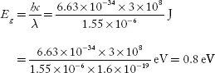

**Example.2‑‑‑‑‑‑‑‑‑‑‑‑‑‑‑‑‑‑‑‑‑‑‑‑‑‑‑‑‑‑‑‑‑‑‑‑‑‑‑‑‑‑‑‑‑‑‑‑‑‑‑‑‑‑‑‑‑‑‑‑‑‑‑‑‑‑‑‑‑‑‑‑‑‑‑‑‑‑‑‑‑‑‑‑‑‑‑‑‑‑‑‑‑‑‑‑‑‑**

**Calculate the wavelength of emitted radiation from GaAs which has a band gap of 1.44ev.**

**Sol:** Energy gap of a semiconductor, Eg = hυ = (or)

Wavelength of laser is, λ =

Given Energy gapEg =1.44ev = 1.44 x 1 Joules

Wavelength λ = = = 8633 A0 .

**UNIT-IV**

**Chapter-2:-FIBER OPTICS**

Fiber optics is a branch of physics which deals the transmission and reception of light waves using optical fibers, which acts as a guiding media.The transmission of light waves by fiber optics was first demonstrated by John. Tyndal in 1870.

**Optical Fiber:-**

Optical fiber is a thin and transparent guiding medium or material which guides the information carrying light waves.

A light beam acting as a carrier wave is capable of carrying more information than radio waves and micro waves because of its high frequency as shown below.

Radio waves -104 Hz , Micro waves--1010 Hz, Light waves-- 1015 Hz.

As the information carrying capacity of light waves is high, a single optical fiber can carry 140 M bytes of information upto 220Km in one sec.

**OPTICAL FIBER STRUCTURE AND CONSTRUCTION:-**

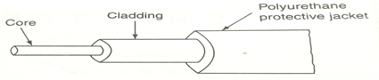

An optical fiber is a very thin, flexible transparent plastic or glass in which light is transmitted through multiple, total internal reflection .It has cylindrical shape consisting of three layers (sections)

1.The core

2.The cladding

3.The outer jacket (or) buffer jacket

1) THE CORE :-

It is the first layer surrounded by a second layer called the cladding.

Light is transmitted within the core which has refractive index (n1). It acts a denser medium.

2)THE CLADDING :-

It is the second layer surrounded by a third layer called the outer jacket. It has refractive index (n2) and n1> n2. it acts as a rarer medium. It keeps the light within core because n1> n2.

3) THE OUTER (OR) BUFFER JACKET: - It is the third layer. It protects the fiber from moisture and

abrasion. To provide necessary toughness and tensile strength, a layer of strength member is

arranged surrounding the buffer jacket. The core as well as cladding is made of either glass or plastic.

**\*\*\* PRINCIPLE OF OPTICAL FIBER : [5M]**

**Total Internal Reflection :**

The principle optical fiber is total internal reflection. Consider a denser and rarer media of refraction indices n1 and n2respectively and n1 > n2 . Let a light ray move from denser to rarer medium with ‘i’ as the angle of incidence and ‘r’ as the angle of refraction. The refracted ray bends away from the normal as it travels from denser to rarer medium with increase of angle of incidence ‘i’.

ay will be reflected back into the denser medium, as shown in fig.3.

For the two media, applying Snell’s law, from fig.2.

n1 Sini = n2 Sinr

n1 Sinθc = n2 Sin900 [ since, i=θc  and r= 900 ]

n1 Sinθc = n2 . 1

⇒ Sinθc=

Therefore, Critical angle, θc = Sin-1[, where n1> n2

* For air, n2 = 1, then θc = Sin-1 [

**CONDITIONS FOR TOTAL INTERNAL REFLECTION:-**

1. The light ray should move from denser to rarer medium

2. The refractive index of core (n1) must be greater than the refractive index of cladding (n2),

i.e n1> n2

3. The angle of incidence (i) must be greater than the critical angle (θc ). i.e., i > θc.

4. Critical angle θc = Sin-1 [

**\*\*\* NUMERICAL APERTURE:-**

The light gathering power of an optical fiber is called numerical aperture.It is proportional to acceptance angle. So, numerical aperture is equal to the sine of acceptance angle.

ie , Numerical Aperture = Sin θa =

**Acceptance angle(θa) and Acceptance cone :-**

Acceptance angle is the maximum angle of incidence at the core of an optical fiber, so that light can be guided through the fiber.This angle is called as acceptance angle (θa).

Consider a cross-sectional view of an optical fiber having core and cladding of refractive indices n1 and n2 respectively such that n1>n2 . Let the fiber be in air medium (n0 ). The incident light while entering into the core at ‘A’ makes an incident angle of ‘ θi’ with the fiber axis.

In core it travels along AB and is incident at point B on core cladding interface. Let ‘θr’ be the angle of refraction at point ‘A’ and ‘θ’be the angle ofincidence at B. When θ> θc, then total internal reflection takes place into the core and light takes the path BD. Due to multiple total internal reflection , the propagation of light ray takes place through the fiber.

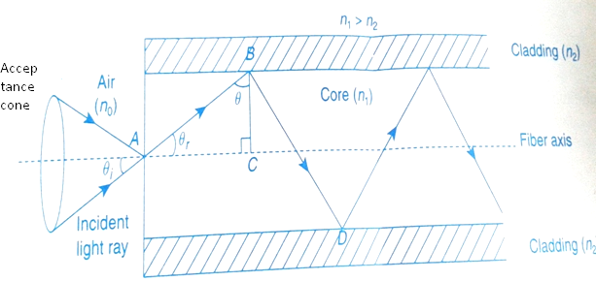

According to Snell’s law at the point A (core - air interface) ;

no sinθi = n1 sinθr

From triangleABC, θr + θ = 900 ⇒θr = 900 - θ

Then, no sinθi = n1 sin(900 -θ)

no sinθi = n1 cosθ

⇒sinθi = cosθ----------------(1)

To get the total internal reflection at the point B (core - cladding interface) , θ> θc

Let the maximum angle of incidence at point ‘A’ be ‘θa for which θ> θc

i.e., θi = θa and θ = θc

From equation(1), we get, sinθa = . cosθc ---------------(2)

But we have, sinθc=

then, cosθc= = =

cosθc= -----------------(3)

Substitute equation (3) in equation (2), we get

sinθa = . =

For air medium, = 1, ⇒ sinθa=

Therefore, Acceptance angle θa =sin-1 ( )

But, numerical aperture is equal to the sine of acceptance angle.

∴Numerical Aperture NA = Sin θa =

**Acceptance cone:-**

The cone formed by rotating the acceptance angle about the fiber axis is called acceptance cone.The light launched at fiber end with in this acceptance cone alone is accepted by fiber and propagate through fiber.

**Fractional Refractive Index Change Δ:-**

It is the ratio of refractive index difference in core and cladding to the refractive index of core.

i.e., Δ =

**Relation between NA & Δ :-**

Δ = ⇒ =Δ .-------------(1)

We have Numerical Aperture, NA =

NA =

=

Consider, , then NA =

NA = =

∴ NA =

**\*\*\*Types of Optical fibres :-**

Based on the material used, Optical fibers are classified into two types.

They are

1. Glass fiber 2.Plastic fiber

*(1) Glass fiber:-*These are made by fusing mixtures of metal oxide s and silica glasses

Examples of fiber compositions:-

a) GeO2- SiO2 core, SiO2 - Cladding

b) P 2O5- SiO2 core, SiO2 - Cladding

c) SiO2 core, P 2O5- SiO2 - Cladding

*(2) Plastic fiber:* These are made of plastics. They have low cost, toughness and durability

Examples: -

(a) A polysterene core (n= 1.60) & a methyle methacrylate cladding (n=1.49)

(b) A poymethyl methacrylate core (n=1.49) & its co – polymer as cladding (n =1.40)

Based on the number of paths or modes of propagation, the fiber are classified into two types .

They are,

1.Single Mode fibers

2.Multi Mode fibers

Based on the variation of refractive index of core, the fibers are classified into two types .

They are

1.Step index fiber

2.Graded index fiber

**Single Mode Optical Fiber:-**

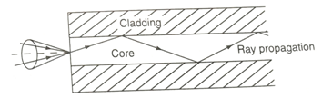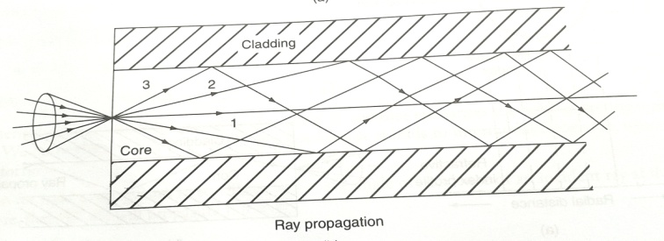

Fig.1 Single mode fiber Fig.2 Multi mode fiber

It is shown in fig.1

* In single mode fibers only one mode of propagation is possible.
* In this fiber, the width or diameter of the core is very small
* In this fiber, the width or diameter of the cladding is very large
* In this fiber, no dispersion takes place. So that power loss is very less
* These are more suitable for communication
* These are costly. Because fabrication is difficult.
* The process of launching of light into fiber is difficult.
* Joining of two single mode fibers is not easy.
* It can carry information to longer distances.

**Multi Mode Optical fibers:-**

. It is shown in fig.2

* In multi mode fibers many number of modes of propagation are possible.
* In this fiber, the diameter of core is very large.
* In this fiber diameter of cladding is very small.
* In this fiber, dispersion is large.
* These are not costly, because fabrication method is easy.
* The process of launching the light into these fibers is easy.
* Joining of two multimode fibers is easy.
* Information can be carried to shorter distances only.

**Step-index Optical fibers:-**

In a step index optical fiber, the refractive index of the core remains constant throughout the core and decreases from step n1 to n2 at the core cladding interface. It is called as Step-index fiber.The transmission of information will be in the form of signals or pulses.

It has again two types. They are

i. Single-mode Step index fiber ii. Multimode-Step index fiber

**i.Single mode Step- index fiber:-**

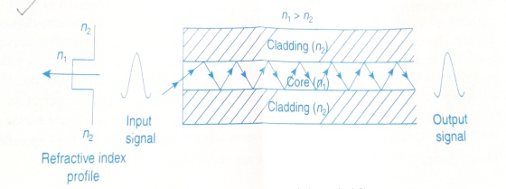

In this fiber, a single light ray from the signal enters into the fiber and

traverses a single path and forms the output signal . In this fiber signal distorsion is very low .

**ii) Multimode Step-index fiber:-**

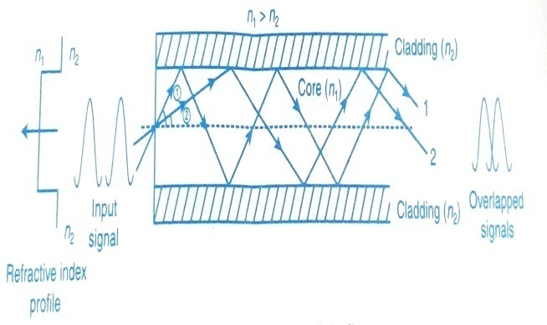

In this fiber due to large width of core , greater number of light rays from the input signals enter into the core and takemultipaths, as shown in the fig.2. The light ray1 which makes greater angle with the fiber axis suffers more reflections through the fiber and takes more time to traverse the optical fiber, where as the light ray2 makes less angle with axis, suffers less number of reflections and within a short time, it traverses the optical fiber.

At the output end we receive ray2 first and later we get ray1. Due to the path difference between the light rays, we get signal distortion. It is known as intermodal dispersion.

It is difficult to retrieve the information carried by the output signal. In this fiber, the propagation of light ray is due to multiple reflections, so it is of reflective type.

The no. of modes through step index fiber = V2/2, ; V = no. of possible propagation modes in the core.

**Graded Index Optical fiber:-**

In this fiber, the refractive index of the core decreases from the fiber axis to the cladding interface in a parabolic manner.When light ray enters into the core and moves towards the cladding interface, it encounters a more & more rarer medium due to decrease of refractive index.

As a result, the light ray bends more away from the normal and finally bends towards the axis and moves the core-cladding interface at the bottom. Again it bends in the upward direction. Thus, the light due to refraction takes sinusoidal paths. This fiber is of refractive type.

This fiber also divided into two types:-

i. Single mode-Graded index fiber

ii.Multimode-Graded index fiber

**i. Single mode-Graded index fiber:-**

It is shown in fig.1

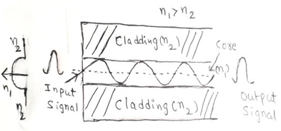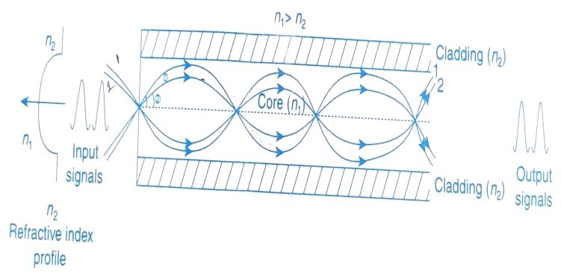

Fig.1- Graded index-Single mode fiber Fig.2- Graded index-Multi mode fiber

**ii). Multimode-Graded index fiber:-**

It is shown in fig.2

When two light rays 1&2 making different angles with the axis enters into the fiber, they travel with different velocities in different paths due to variation in their refraction indices and come to focus at the same point .As a result, all the light rays will be received at the output end at the same time .

There is no intermodal dispersion and the output signals match with input signal .It is easy to retrieve the information from the signal. In this fiber, we get a refocusing effect of light rays.

The no. of possible modes through graded index fiber = V2/4 .

**\*\* Attenuation in Optical Fiber :-**

When light propagates through an optical fiber, then the power of light at the output end is found to be always less than the power launched at the input end. The loss of power is called attenuation. It is measured in terms of decibles per kilometer.

**Attenuation:-**

It is defined as the ratio of the optical power output (Pout) from a fiber of length “L” to the power input (Pin).

i.e, Attenuation (α) = -10/L . Log [ Pin /Pout ] dB/km

Attention occurs because of the following reasons

1. Absorption (2) Scattering loss (3) Radiative losses (or) Bending losses
2. **Absorption :-**

it occurs in two ways

* 1. absorption by impurity (or) impurity absorption
  2. intrinsic absorption (or) internal absorption

**i) .Impurity absorption :-**

The impurities present in the fiber are transition metal ions , such as iron , chromium , cobalt & copper . During single propagation when photons interact with these impurities atoms, then the protons are absorbed by atoms . Hence loss occurs in light power.

**ii). Internal absorption :-**

the fiber itself as a material .it has a tendency to absorb light energy however small it may be .The absorption that takes place in fiber material assuming that there are no impurities in it ,is called intrinsic absorption .

1. **Scattering Loss :-**

while the signals travel in the fiber , the photons may be scattering due to variations in the refractive index inside the fiber .This scattering is called as Rayleigh scattering . It is also a wave length dependent loss.

Rayleigh scattering loss α 1/ λ4

1. **Radiation losses (or) Bending losses :-** These losses occur due to
   * 1. macroscopic bending
     2. microscopic bending

**a). Macroscopic bending :-**

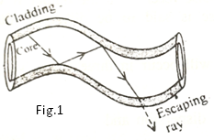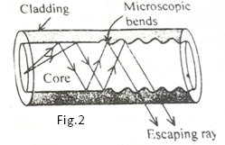

If the radius of core is large compared to fiber diameter causes large –curvature at the bends. At these bends, light will not satisfy the condition for total internal refraction &light escapes out from the fiber .It is called as macroscopic bending.

**b).Microscopic bending :-**these are caused due to non –uniform pressures created during the cabling of the fiber or during the manufacturing the fiber .It causes irregular reflections . This lead to loss oflight by leakage through the fiber.

**Distortion & Dispersion :-**

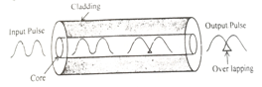The optical signal becomes increasingly distorted as it travels along a foiber .This distortion is due to dispersion effect.

**Dispersion :-**

When an optical signal or pulse is sent into the fiber, the pulse spreads as it propagates throught the fiber .It is called as dispersion .

It will occur in 3- ways ,

1. Intermodal dispersion

ii.Material dispersion (or) Chromatic dispersion

iii.Wave guide dispersion

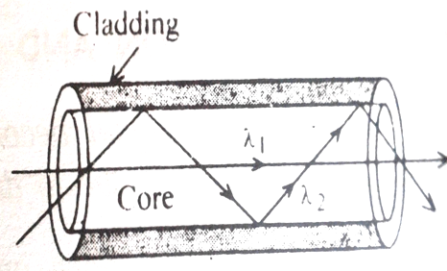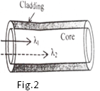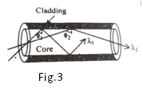

Fig.1

1. **Intermodal dispersion: -** it will occur, when more than one mode is propagatingthrough a fiber. Since,modes are propagating through a fiber they will have different wavelength and will take different time to propagate through the fiber, which leads to intermodal dispersion.
2. **Material (or) Chromatic dispersion :-** in this , the dispersion occurs due to different wavelengths of light traveling at different speedsinside the fiber as shown in fig.2
3. **Wave guide dispersion: -** it arises due to the guiding property o the fiber &due to their different angles at which they incident at the core – cladding interface of the fiber .

In general, Intermodal dispersion> Material dispersion> Wave guide dispersion

**Advantages of Optical fibers :-**

1. It has high band width. Light can transmit information at a higher rate, upto 1014 to 1015 Hz.
2. transmission loss is low compared to copper cables
3. lack of cross –talk between parallel fibers
4. high speed data transmission temperature resistant
5. it is small in size & light in weight
6. it is non- conductive , non-radiative &non- inductive
7. longer life– span
8. ruggedness &flexibility
9. easy formation & reliable
10. it has low cost

**Block diagram of Fiber Optic Communication System:-**

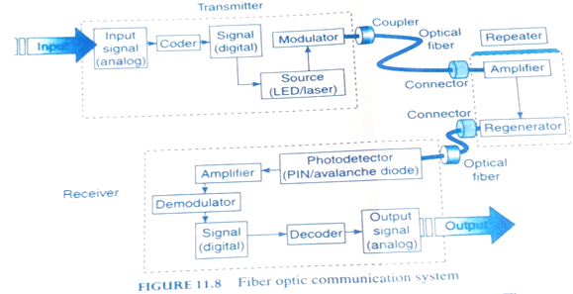

**1. Optical transmitter:-**

An optical transmitter converts an analogs or digital signal into optical form. It consists of an encoder, light source and modulator. The input analog signal is converted into a digital signal by means of an encoder. The converted digital signal is fed to the source. The source can be a light emittingcode (LED) or a semi conductor laser diode. The optical carrier wave from the source is modulated based on intensity, amplitude or frequency with the help of a modulator. This optical signal is coupled to the optical fiber by means of couplers. The couplers launch the optical signal into the fiber without any distortion and loss .The optical signal through fiber is properly connected to a repeater with the help of any connector.

**2.Fiber repeater:-**

The optical signal while travelling through very long optical fibers through long distances can suffer transmission losses and fiber losses like dispersion. As a result we get a weak optical signal at the output end of the fiber. To minimize the losses, we use fiber repeaters at regular intervals between the fibers. Therepeater consists of an amplifier and regenerator. The amplifier amplifies the weak optical signal, it is reconstructed to original optical signal with the help of regenerator and it is transmitted through the optical fiber. At the last stage, it is received by optical receiver.

**Optical receiver:-**

The receiver unit consists of a photo detector, amplifier, demodulator and decoder. Thephoto detector consists of PIN photo diode or avalanche photo diode. This works on the principle of creation of an electron-hole pair at the p-n junction by successive collisions of the incident optical signal (photons).The released electrons output a current which is in direct relationship with the incident optical signal. This electric current (signal) is amplified and demodulated to obtain a digital signal. This signal is then decoded and the transmitted signal is outputted.

**Differences between Step index and Graded index optical fibers:-**

|  |  |
| --- | --- |
| ***Step index*** | ***Graded index*** |
| Refractive index of the core remains Constant and decreases a step at cladding**.** | Refractive index of the core decreases parabolically from the axis of thefiber to cladding. |
| It is of reflective type. | It is refractive type. |
| Signal distortion is high in multi mode step index fiber. | Signal distortion is very low in graded index fiber. |
| NA is more for multimode step index fiber. | NA is less for graded index fiber. |
| No focusing of light rays takes place. | Focusing of light rays takes place |

**Distinguish between optical fibers and conventional electrical cables used for transmission of signals**:-

|  |  |
| --- | --- |
| **Optical fibers** | **C o-axial cables.** |
| 1. less weight | **1.** heavier than optical fibers |
| 2. No external shielding is required. | 2. External shielding required for reducing R.F interference |
| 3. Low loss of 0.2db/km. | 3. A considerable loss of 5db/km |
| 4. Electrically isolate. | 4. It is prone to electrical hazards |
| 5. Large band width of about 1013 to 1016 Hz | 5. Bandwidth of 500 MHz are obtained |
| 6. Large spacing between repeaters | 6. Data rates of mega bits per second are obtained |
| 7. Higher data rates tetra bits per second | 7. Spacing distance between repeaters |
| 8. Secure sign | 8. Signal can tapped easily |
| 9. No cross talk | 9. cross talk occur |
| 10. Costly | 10. Cheaper |

**\*\*\*Application of Optical fibers :-**

**1.In Communication :-**

i.Due to high band width, light can transmit information at a higher rate upto 1014 to 1015 Hz than radio or micro frequencies.

ii.Long distance signal transmission.iii.The information capacity of light waves is very high. A single fiber carries 140M bytes of information upto 220 km in one sec. iv.It is used to transmit the audio or video signals and digital or analog signal through the fiber. v.It is used in under water communication networks

**2. In Medical field:-**

**Endoscope:-**It is an optical instrument used to see the internal parts of human body.Based on application endoscopes are classified into:

*i.Gastroscope:-* It is used to examine the stomach.

*ii.Bronchoscope:-* It is used to see upper passages of lungs.

*iii.Orthoscope:-* It is used to see the small spaces or fractures within joints.

*iv.Couldoscop:-* It is used to test female pelvic organs.

*v.Peritoneoscope:-* It is used to test the abdominal cavity, lower parts of liver and gall bladder.

**3. Sensing applications (Fiber optic sensors):-**

Sensors are devices used to measure or monitor quantities such as displacement, pressure, temperature, flow rate, liquid level, chemical composition etc.

Ex:- Displacement sensor, Pressure sensor, Temperature sensor etc.

Optical sensor is a transducer which converts any form of signal into optical signal in the measurable form.

There are two types of sensors (i) Active sensors (ii) Passive Sensors

**i) Active sensors**

The Physical parameter to be sensed directly acts on the fiber itself to produce changes in the transmission characterstics.Here the fiber acts as a transducing element and modifies the light passing through it.

Ex:Temperature sensor,pressure sensor.Liquid level sensor

**(ii) Passive Sensors**

In Passive sensors, separate sensing element will be used and the fiber acts as guiding to the sensors.

Ex:Displacement sensor

**\*What is a Displacement Sensor ? Draw its Sensitivity curve. [6M]**

**Displacement Sensor:-**

It is a device which detects (or) measures small changes in displacement

Of any object using optical fiber. Fiber optic sensors can be divided into two types, namely active sensors and passive sensors. It uses reflective concept. It consists of a pair of single fibers as shown in fig.a.

Light from the source passes through one optical fiber and incident on the target.The reflected light reaches the detector through another optical fiber. Light reflected from the target and collected by the detector is a function of the distance between the fiber ends and target. Hence, the position or displacement of the target may be registered at the optical detector.

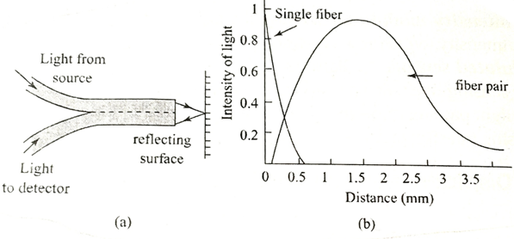

**Sensitivity curve:-**It is shown in fig.b.It is obtained by taking distance of light from the target on x-axis and intensity of detected light on y-axis. The sensitivity of the displacement sensors depend on the probe configuration. Sensitivity curves of single fiber and fiber pairs are different.

**Medical Endoscope:** An endoscope is an instrument designed to provide a direct view of internal parts of the body which are not visible to human body naked eye. It is also designed to perform tasks such as the removal of samples, injection of fluids and diathermy. This instrument transmits the images form inaccessible areas such as food path, stomach, intestines, heart and lungs through a long flexible fiber.

.It has two fibers namely(1) outer fiber(f0) (2)inner fiber (fi )

Outer fiber (f0) consists of many fibers bundled together in random order, called incoherent bundle which is used to illuminate or focus the light onto the inner parts of the body.

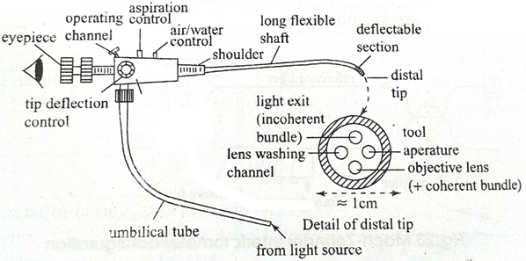

Inner fiber (fi ):It also consist of bundle of fibers in a perfect order,which is known as coherent bundle.This fiber is used to collect the reflected light from the object.A lens is used to focus the light effectively

The long flexible shaft of the instrument is usually constructed of steel mesh. It is sheathed with a protective, low-friction covering of PVC. The shaft is about 10mm in diameter. It is about 0.6to 1.8m long.

This fiber end has a short deflectable section about 50-85mm long leading to its distal tip.

Light from the source is passed through the outer fiber (f0) & is illuminated on the internal parts of the body.The reflected light isbrought to focus by using telescope system to the inner fiber (fi).Here each fiber picks up a part of the picture fro the body & will be collected bit by bit then transmitted in an order by the array of fibers.As a result the whole picture is reproduced at the receiving end.

**Applications of fiber optic endoscopy:**

i.Gastroscope:- It is used to examine the stomach.

ii.Bronchoscope:- It is used to see upper passages of lungs.

iii.Orthoscope:- It is used to see the small spaces or fractures within joints.

iv.Couldoscop:- It is used to test female pelvic organs.

v.Peritoneoscope:- It is used to test the abdominal cavity, lower parts of liver and gall bladder.

**Formulae:-**

Sinθa =

*Acceptance angle of optical fiber (θa) = Sin-1 (

*Numerical Aperture of optical fiber (NA) = Sinθa (or)

*Critical angle (θc) = Sin-1[

*Fractional refractive index change ∆ =

*Relation between NA and ∆ is , NA =

**\***Snell’s law : n1 sin θ1 = n2 sin θ2 (or)

**Solved Problems:-**

**Example.1 ‑‑‑‑‑‑‑‑‑‑‑‑‑‑‑‑‑‑‑‑‑‑‑‑‑‑‑‑‑‑‑‑‑‑‑‑‑‑‑‑‑‑‑‑‑‑‑‑‑‑‑‑‑‑‑‑‑‑‑‑‑‑‑‑‑‑‑‑‑‑‑‑‑‑‑‑‑‑‑‑‑‑‑‑‑‑‑‑‑‑‑‑‑‑‑‑‑‑**

***Calculate the fractional index change for a given optical fiber if the refractive indices of the core and cladding are 1.563 and 1.498 respectively.***

**Solution :** Given data : Core refractive index n1 = 1.563**,** Cladding refractive index n2 = 1.498

Fractional index change 𝜟 = ?

Principle : 𝜟 = = = =>𝜟 = 0.0415

**Example.2 ‑‑‑‑‑‑‑‑‑‑‑‑‑‑‑‑‑‑‑‑‑‑‑‑‑‑‑‑‑‑‑‑‑‑‑‑‑‑‑‑‑‑‑‑‑‑‑‑‑‑‑‑‑‑‑‑‑‑‑‑‑‑‑‑‑‑‑‑‑‑‑‑‑‑‑‑‑‑‑‑‑‑‑‑‑‑‑‑‑‑‑‑‑‑‑‑‑‑**

***An optical fiber refractive index of core and cladding are 1.53 and 1.42 respectively. Then calculate the critical angle*** .

**Solution :** Critical angle𝜭c = sin-1(n2/n1)⇒𝜭c = sin-1(1.53/1.42) = sin-1(0.928) =>𝜭c = 68.14 0

**Example.3‑‑‑‑‑‑‑‑‑‑‑‑‑‑‑‑‑‑‑‑‑‑‑‑‑‑‑‑‑‑‑‑‑‑‑‑‑‑‑‑‑‑‑‑‑‑‑‑‑‑‑‑‑‑‑‑‑‑‑‑‑‑‑‑‑‑‑‑‑‑‑‑‑‑‑‑‑‑‑‑‑‑‑‑‑‑‑‑‑‑‑‑‑‑‑‑‑‑**

***A light ray enters core of refractive index 1.55 through the end from a medium of refractive index 1.6with an angle of incidence 600. Calculate its angle of refraction 𝜭2 at the interface.***

**Solution :** According to Snell’s law : n1 sin 𝜭1 = n2 sin 𝜭2

sin 𝜭2 = ⇒sin 𝜭2 = 0.8389 =>𝜭2 = sin-1(0.8389) = 57.030

**Example.4‑‑‑‑‑‑‑‑‑‑‑‑‑‑‑‑‑‑‑‑‑‑‑‑‑‑‑‑‑‑‑‑‑‑‑‑‑‑‑‑‑‑‑‑‑‑‑‑‑‑‑‑‑‑‑‑‑‑‑‑‑‑‑‑‑‑‑‑‑‑‑‑‑‑‑‑‑‑‑‑‑‑‑‑‑‑‑‑‑‑‑‑‑‑‑‑‑‑**

***The refractive indices of core and cladding of a step index optical fiber are 1.563 and 1.498 respectively.Calculate:***

***i.Numerical aperture ii. Acceptance angle in air iii. Critical angle iv. Relative refractive index change***

**Solution : Given data,**

***i.Numerical aperture*** *=*

***ii. Acceptance angle in air (*θa) *:*** Since NA = Sinθa=⇒θa = Sin-1(NA) = Sin-1 ( ) =

***iii. Critical angle (***𝜭c) = Sin-1[ =

***iv. Relative refractive index change,*** ∆ = =

**Example.5 ‑‑‑‑‑‑‑‑‑‑‑‑‑‑‑‑‑‑‑‑‑‑‑‑‑‑‑‑‑‑‑‑‑‑‑‑‑‑‑‑‑‑‑‑‑‑‑‑‑‑‑‑‑‑‑‑‑‑‑‑‑‑‑‑‑‑‑‑‑‑‑‑‑‑‑‑‑‑‑‑‑‑‑‑‑‑‑‑‑‑‑‑‑‑‑‑‑‑**

***Calculate the refractive indices of core and cladding of an optical fiber with a numerical aperture of 0.33 and their fractional difference of refractive indices being 0.02.***

**Solution**